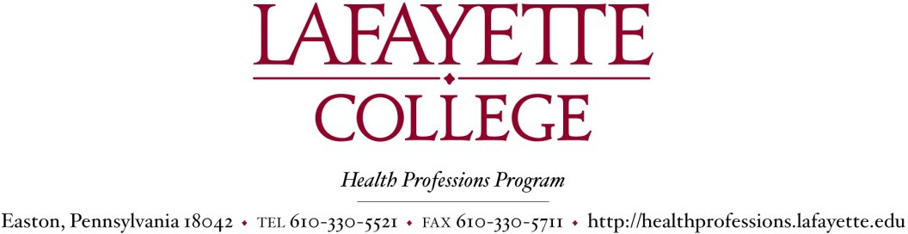

IMPORTANT: In accordance with the Family Educational Rights and Privacy Act of 1974 (FERPA), application submission materials that are sent from non-Lafayette email addresses require additional authentication. Please include a scanned image of the front of your government-issued photo ID (such as a driver’s license or passport) with your email.

This form must be submitted via email to Ms. Herschlag at healthprofessions@lafayette.edu by February 1, 2026 in order for us to include you in the HPAC application process.

Applicant’s Waiver of Access to
- Individual Letters of Recommendations: submission to HPA beginning 5 January 2026, by 1 March 2026
- HP Composite Letter of Evaluation (CLoE): submission by HPA to CAS beginning July 2026

Applicant’s Authorization to Release
- Dean’s Clearance Report: submission by the Dean’s Office to HPA by 1 February 2026
- Composite Letter of Evaluation Packet: submission by HPA to CAS with CLoE (above)

Please read the explanation of the FAMILY EDUCATIONAL RIGHTS AND PRIVACY ACT (FERPA) below.
The Family Educational Rights and Privacy Act of 1974 (FERPA, The Buckley Amendment, or ‘The Act’) allows a student to examine files pertaining to themselves, including files maintained by admissions officers, deans, registrars, and other administrators. Summarized in the Lafayette College Student Handbook, The Act protects confidential information about a student by restricting access. Yet for items such as letters of recommendation, a student can waive that right of access when applying for a job, admission to another school or for some awards. This helps ensure that prospective decision makers see unbiased evaluations. Each student should consider the consequences of relinquishing their rights protected by the Act. Because of how important protection of your privacy is, we in HP Advising require that every applicant submit a signed document that indicates EITHER that they waive their right of access OR that they do NOT waive their right of access. We prefer that you waive your right of access, but you must indicate one or the other. The Act gives you the right to see your file, unless you waive that right. How might you evaluate this?

If you waive the right to see your file, then you cannot see what is written about you, but that file is viewed as being a frank and honest assessment and will carry significant weight as a clear, unbiased recommendation.
The CLoE that is written for an applicant who waives their right in this regard will be a complete and thorough assessment and includes specific elements and interpretation of your recommenders’ letters. Schools really value this.
If you do not waive the right to see your file, then you will be able to view what is written about you, but that file is now viewed as compromised in its content, and in the credibility of its recommendation, and will therefore carry substantially less weight as a recommendation.
The CLoE that is written for an applicant who does not waive their right is limited to the public metrics in the cover sheet and will not include any specific elements from letters of recommendation nor will it include any thoughtful interpretation of your individual letters. It will also clearly state that you did not waive your right to access your file. This can be viewed negatively.

We in Health Professions Advising believe that waiving your right of access means letters written on your behalf will be protected by confidentiality, and will therefore be of greater assistance to you in the admissions process to health professions schools. Because of the nature of the information, we require that you complete the following as a legal document directing Health Professions Advising on your rights protected under FERPA. This one signed document covers the necessary waivers of access.

Applicant's Waiver of Access to Individual Letters of Recommendations and to the HP Composite Letter of Evaluation (CLoE)

I have read the attached explanation of the Family Educational Rights and Privacy Act (FERPA) and understand that federal legislation provides me with a right of access to confidential material that may be waived, but that no school or person can require me to waive this right.

Please check one of the two following statements, print your name and date, and sign as indicated:

In connection with my application for admission to various health professional schools
I hereby waive my right of access to confidential statements and material evaluating me/and my activities for the HPAC. These materials and evaluations will be forwarded by Lafayette College to the health professional schools to which I have applied. It is my intention that this waiver shall be applicable to all such statements and material whether it is in the possession of Lafayette College or the health professional school.
I do not waive my right of access to confidential statements and material evaluating me and my activities forwarded by Lafayette College to the health professional school to which I have applied.

Date
Applicant’s Printed Name

Applicant’s Signature
(Either hand-written signature or authorized electronic signature)

Applicant’s Authorization to Release Dean’s Clearance Report and Composite Letter of Evaluation
I hereby authorize release of Composite Letter of Evaluation written by the Lafayette College Health Professions Advisory Committee and my Dean’s Clearance Report on academic conduct (if applicable) to be sent on my behalf to my designated list of the health professions schools.

In order for us to release your information, please print your name and date, and sign as indicated:

Date

Applicant’s Name
Applicant’s Signature
(Either hand-written signature or authorized electronic signature)

